Call for Student Proposals
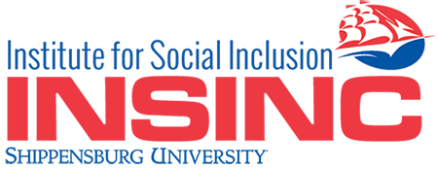

Social Inclusion and Social Justice Conference 2017 Shippensburg University of Pennsylvania Friday, April 7, 2017 Conference THEME: “Access”
The Institute is currently seeking student poster presentations, both undergraduate and graduate, to participate in our 2017 regional conference. Our inaugural conference in 2016 successfully brought together diverse communities to learn new and exciting ways of collaborating by discussing and developing potential solutions for the pressing issues of today.
We now seek to continue our work in 2017 to further promote the concept of social inclusion and social justice through the theme of gaining greater access to services and support for marginalized populations.
INSINC’s second annual conference seeks to highlight a variety of professional speakers on the topics of social inclusion and social justice through increased accessibility including: mental health; LGBTQ; race; higher education; health care; older adults; criminal justice reform; child welfare; education; disabilities; and mentoring young professionals entering the social justice work force. INSINC, interdisciplinary in nature, seeks to advance and support activities that promote social inclusion of marginalized populations through research, training, and the development of programs which would serve as models for the field.
Deadline for student poster presentation proposal submission is February 3, 2017. Students will be notified regarding the acceptances of the proposals by March 3, 2017. Please submit university affiliation, poster presentation title and abstract of 100 words, to this link: insinc@ship.edu

